**DAY – 5**

Git – version control(in 2018, JAVA19 but in 2025, JAVA25)

GitHub – remote access(environment for program)

**JAVA** :

* 1995
* Owned by Oracle
* More than 3 billion devices runs
* OAK was renamed as JAVA
* Application(software), Web application (if I need to install some web software then my desktop will have the capacity to store, so we need some system requirements and it is **safe**  too).

**What are the java terminologies?**

1. Bytecode
2. Java Developer Kit **(JDK) {>1.7, >2021, JVM and JRE, compiler here}**
3. Java Runtime environment **(JRE) {running place of java program}**
4. Java Virtual Machine **(JVM)**

/* All the program are directly converted to machine code, but in JAVA they used to convert it into byte code so that it can run on any platform. */

**DEV TOOLS**

**LIBRARY CLASSES**

**+**

**JAVA VIRTUAL MACHINE**

**+**

**JAVA RUNTIME ENVIRONMENT**

**JAVA DEVELOPMENT KIT**

**PROCESS IN JAVA PROGRAM TO RUN:**

1. Myprogram.java
2. Java compiler
3. Myprogram.class
4. JVM
5. Machine Code

**HOOK:**

1. Data gets manipulated, organized and Interpreted in order to make sense out of data.

**TO WRITE THE PROGRAM WHAT ARE ALL THE CONSIST THERE:**

* Time and Space Complexity
* Documentation
* Output
* Syntax
* Inputs ( we need to focus on data)

**TWO TYPES OF PROGRAMMING :**

* Procedural Programming Paradigm
* Object Oriented Programming (focus on the data and not on design)

**FEATURES OF JAVA**

1. Object Oriented
2. Architectural neutral
3. Platform Independent
4. Secure
5. Robust
6. Distributed

**CLASS AND OBJECTS**

* Class is a blueprint or the model from which object are made
* Objects are the instance of class

**OBJECT CONSISTS OF**

1. **STATE** - represented by attribute of an object
2. **BEHAVIOUR** - Methods of the classes
3. **IDENTITY** - reference of an object

**OOPS CONCEPT(Four Pillars) :**

1. Encapsulation (wrapping or hiding up of data -> ATM)
2. Inheritance
3. Polymorphism
4. Abstraction

**JAVA ENTITY CLASS:**

1. We should create all variables in private.
2. Create a getter and setter methods.
3. Create a toString() method
4. Constructor(optional)

**HOW DO WE ACHIEVE ENCAPSULATION:**

* We create an entity class
* Wrapping the data into a single unit by using an entity class

**DAY – 6**

**WHAT’S INSIDE CLASS:**

* Objects
* Variables
* Methods
* Functions (to call methods)
* Main class, etc…

**OBJECTS:** Instances of a class (the same values, properties, etc… are stored here as like class)

**CLASS:** Blueprint of an object

* **{}** – Blocks
* **()** – Round Brackets

**ACCESS MODIFIERS / SPECIFIERS :**

* Private (within the class)
* Public (same and different packages)
* Protected (same package and different package sub-class)
* Default (same package)

**DAY – 7**

**NON ACCESS MODIFIERS:**

* Stop the access, the keywords are :
* **Abstract** – Hiding the unnecessary implements

1. Abstract class or method **[abstract display() ]** only we can write
2. A abstract method will not have body **[abstract display() ; ]**

* **Static** – It’s a keyword used in main function and others when there is no need to call objects.

1. Variables **[ var a = 10; ]**
2. Methods **[show () ]**
3. Blocks **Static { --------------------- }**

* **Final –** Fixed one, it will never change once it is declares **[ final a = 10;]**

1. **Why?** When we are calculating the marks of the students, the formula are constant to calculate marks for all the students.
2. We can use it in class, variables and methods too.

**Encapsulation:** The process of bundling up of data and behaviour into a single unit.

**Abstraction :** Hiding the implementation details and showing only necessary details

**POLYMORPHISM :** It’s a Greek word, Poly means **many,** morphism means **forms.** Doing single action in different types

* **OVER-RIDING :** It has a same method and parameter
* **OVER-LOADING :** It has a different parameter but same method

**INHERITANCE : ( Parent –** Super class, **Child –** Sub class**)**

* **Single**

Class A {

}

Class B extends A{

}

* **Multi-level**

Class A{

}

Class B extends A {

}

Class C extends B{

}

* **Multiple (not supported in java)**

Class A{

}

Class B extends A,C { // Class B implements A,C **(What is Interface ? )**

}

* **Hierarchical**

Class A{

}

Class B extends A {

}

Class D extends A{

}

**DAY - 8**

**Packages:**

* Package is a collection of classes and interfaces.
* Java have huge number of build in classes in the jre.
* Two forms :
* Built – in package
* User defined Package – The package which is defined by the user is called user – defined and supports a keyword “package” **(lang, util, io, net, applet)**
* Class , object, string, thread – **lang**
* i/o, o/p -  **io**
* Linkedlist, date, calender, hash table – **util**
* URL, SOCKET – **net**
* Applet – **applet**

**NOTE :** Scanner is a class which is used to collect the input.

**DAY – 9**

**Abstract class in Java** – to provide a base class with common methods and fields. And doesn’t have a body.

**Interface :**

* Special kind of class that consist of only the constants and the method signatures.
* Interface can be defined as a container that stores the signatures of the methods to be implemented in the code segment.
* It improves the levels of Abstraction.
* Limited to static final variables, which means that they are constant.
* Looks like a class definition that has only abstract methods and the abstract keyword need not appear in the definition.
* Syntax :

<access>interface<name>

{

Return type <method_name>(<parameter_list>);

<type><variable name> = <value>; }

**EXAMPLE :**

Public interface Testable {

Void method1 (); // note no implementation for the methods, public by default.

}

Void method2 (int i, String s) {

Int X = 10; // Static final variable **(for abstract method we don’t need an object because they are called by an another class that’s why it is static)**

}

**INTERFACE EXAMPLE :**

**Interface.java interface .class**

interface Printable { interface Printable {

int MIN = 5; compiler public static final int MIN = 5;

void print(); public abstract void print();

} }

**WAYS OF USING THE INTERFACE :**

Class interface interface

Extends implements extends

Class class interface

**RULES OF INTERFACE :**

* Cannot be instantiated directly, but create a reference to an interface
* May not declared with final keyword
* Cannot have an instance variables
* If we declare a variable in an interface, it must be initialized at the time of declaration
* Own implementations is must
* Cannot override
* Can’t declare with another interface or class (nested interface)
* Top-level must be public or default, others will provide compiler error
* All non – default methods defined in an interface are abstract and public by default
* New methods are also default abstract.

**TYPES OF INTERFACES :**

* Functional Interface
* Marker Interface

**Functional Interface :**

* It has only pure one abstract method (when an interface with one abstract method then it is **functional interface** otherwise it will be **abstract class**).
* Can have any number of static and default and public methods of java.lang. Object classes
* Also called as functional method.
* Examples : Runnable, ActionListener, ItemListener.

**Marker Interface :**

* Does not contain any methods, fields, abstract methods and any constants
* If an interface is empty then it is marker interface
* Serializable and the cloneable interfaces.

**Creating a multiple interface :**

If a class implements a multiple interfaces, it should override all the abstract methods declared in all the interfaces.

Example :

public class classname implements interfaceName1, interfaceName2,…….interfaceNameN

{

methods1 implementation;

methods2 implementation;

methods3 implementation;

}

**WRAPPER CLASS :**

* We can’t make the primitive data type as object because it is universal data type we can’t directly change it as an object for java.
* For that wrapper class provide a way to use primitive data types as objects.
* A class that wraps a primitive data types into an object is called wrapper class in java.

**Primitive datatype wrapper class**

char Character

byte Byte

short Short

int Integer

long Long

float Float

Example :

int x = 25;

Integer iWrap = new Integer(x); // pass the primitive type to the wrapper class.

**DAY – 10**

**Exception Handling:**

* The process of handling the CTE and RTE during the program execution or flow.
* Two Types :
* Checked – CT
* Unchecked – RT (e.g., a = 5/0;)

**5 Keywords :**

1. Try
2. Catch
3. Finally
4. Throw
5. Throws

**Syntax :**

try {

a = 5/0;

}

// It is must to come after try block

catch (exception e) { **// e is var/object** ( e is close reality to the exception so we are mentioning e here, but we can give any letters)

System.out.println(“Hi………..” + e);

}

/* finally is not compeltion to use after catch and it will not matter whether try and catch print something but it will print whatever inside it. */

finally {

System.out.println();

}

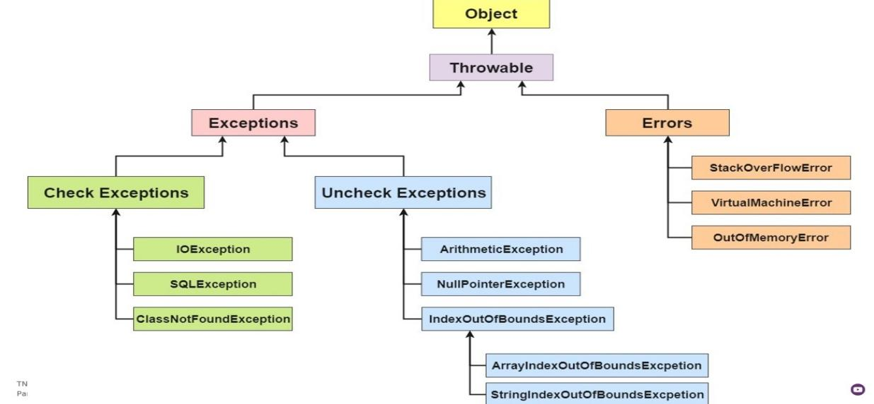

**Error :** It is the type of error this can not be handle by any programmer such as system failure, CPU, etc,…

**Finally Block :**

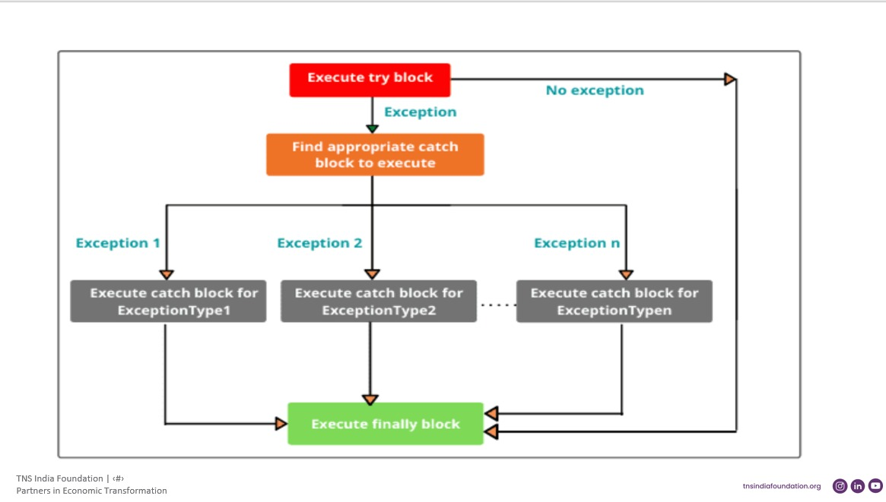

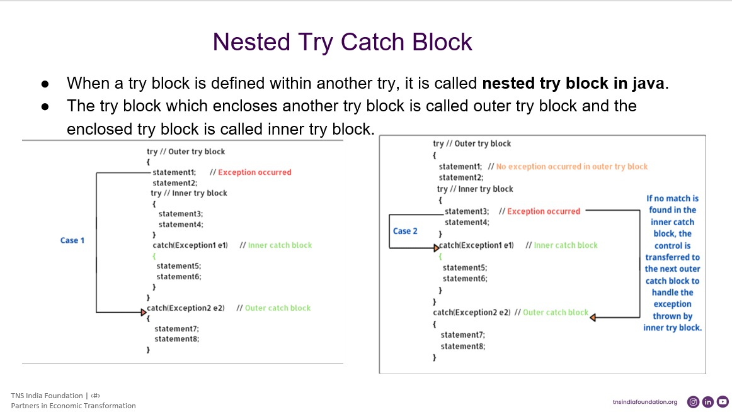

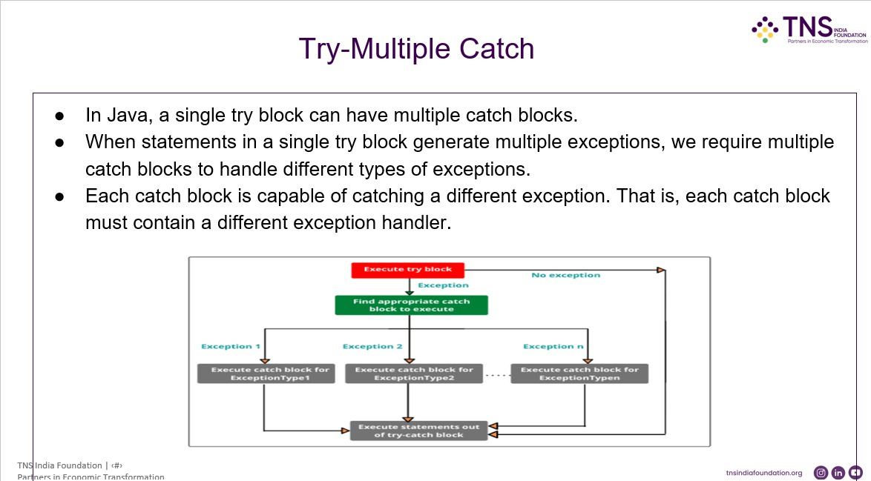

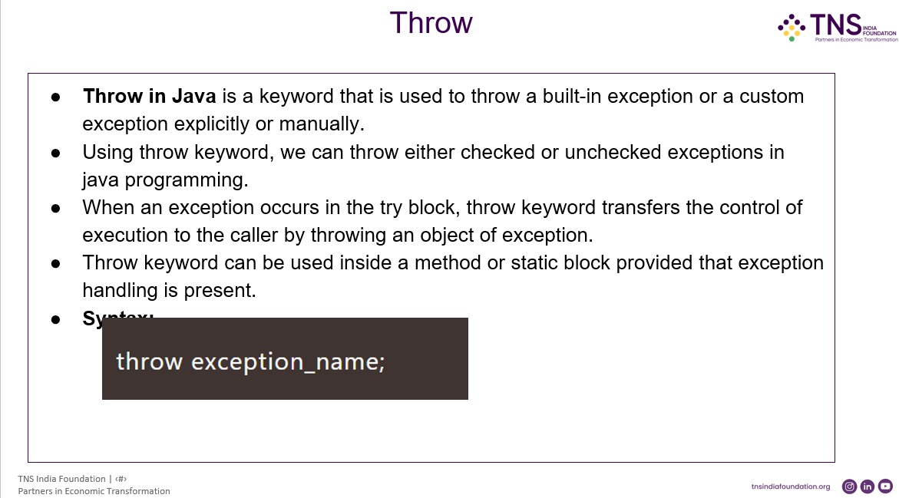

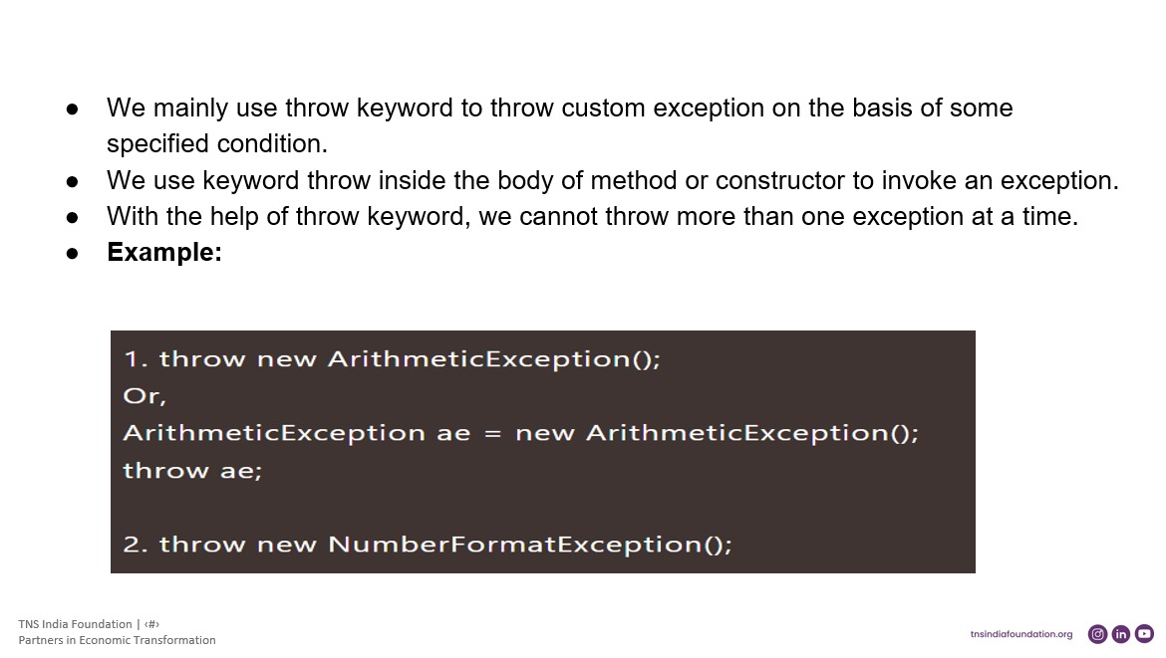

**Throws :**

Throws are followed by some methods because indicating the error in this method

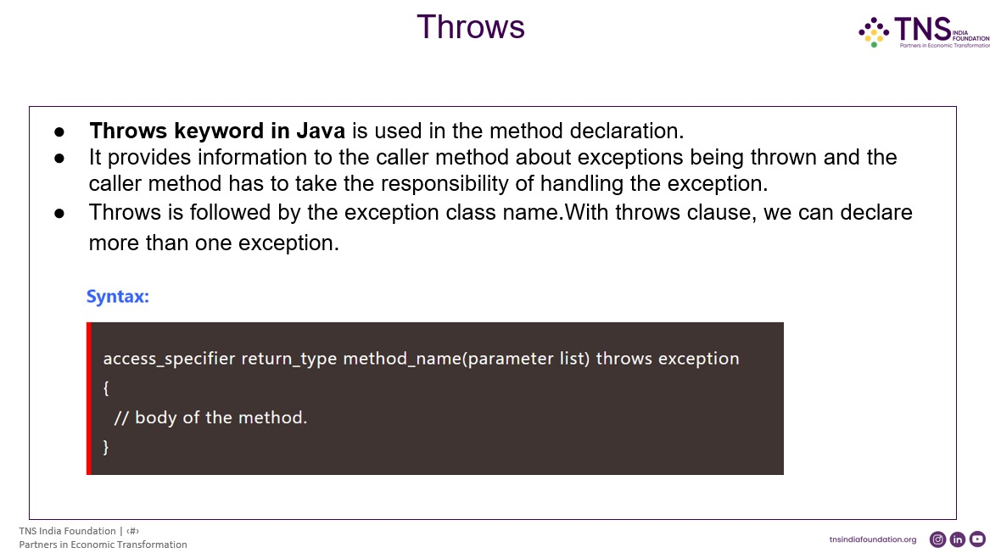

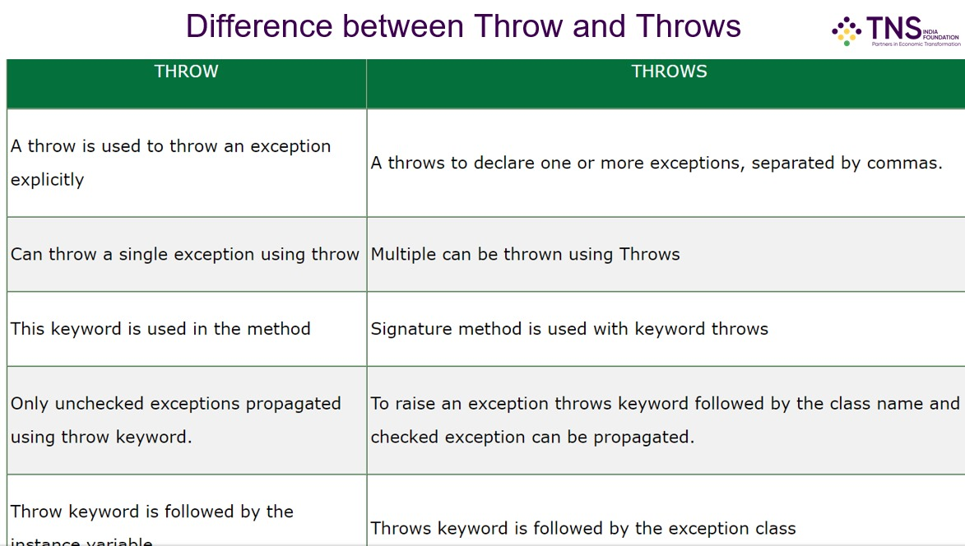

**DAY – 11**

**Multi-threading :**

* Perform multiple tasks.
* Time, space saving, fast accessibility are the advantages. (3sec)
* Consistent, Resource sharing, complexity are the disadvantages. (CPU clash) 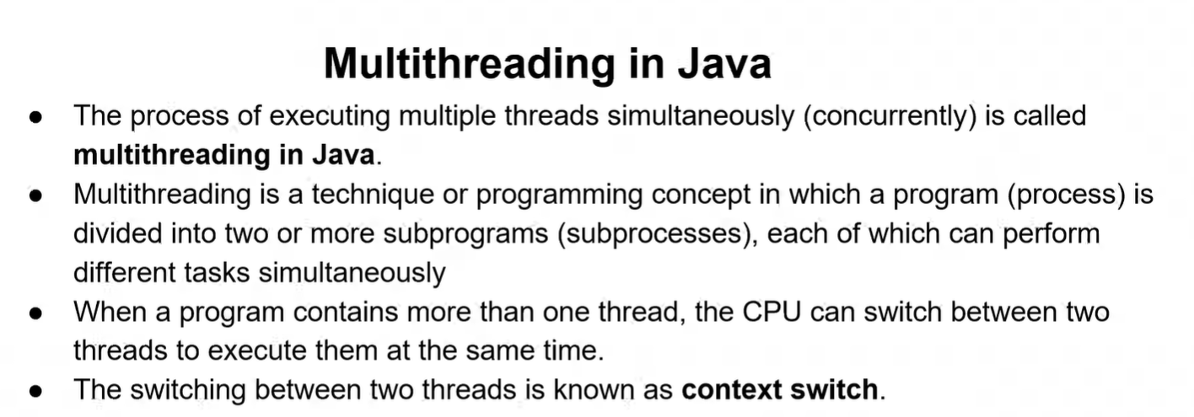

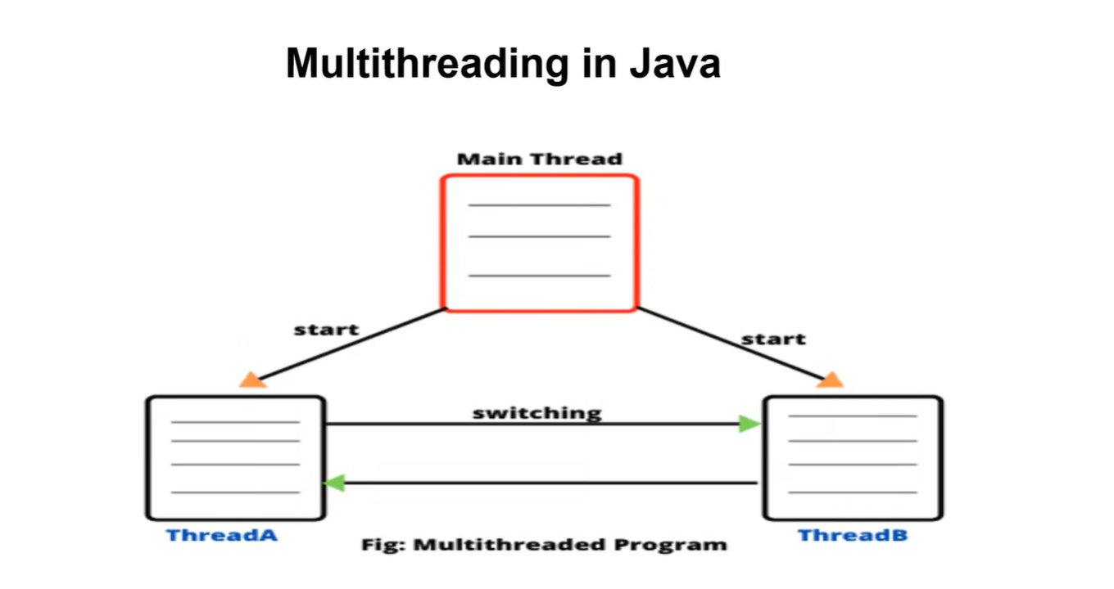

**Threads :**

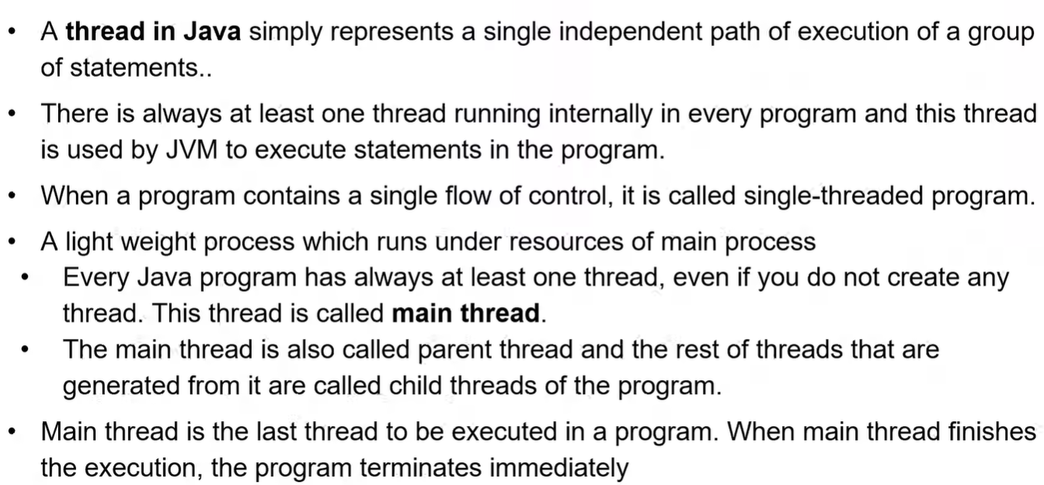

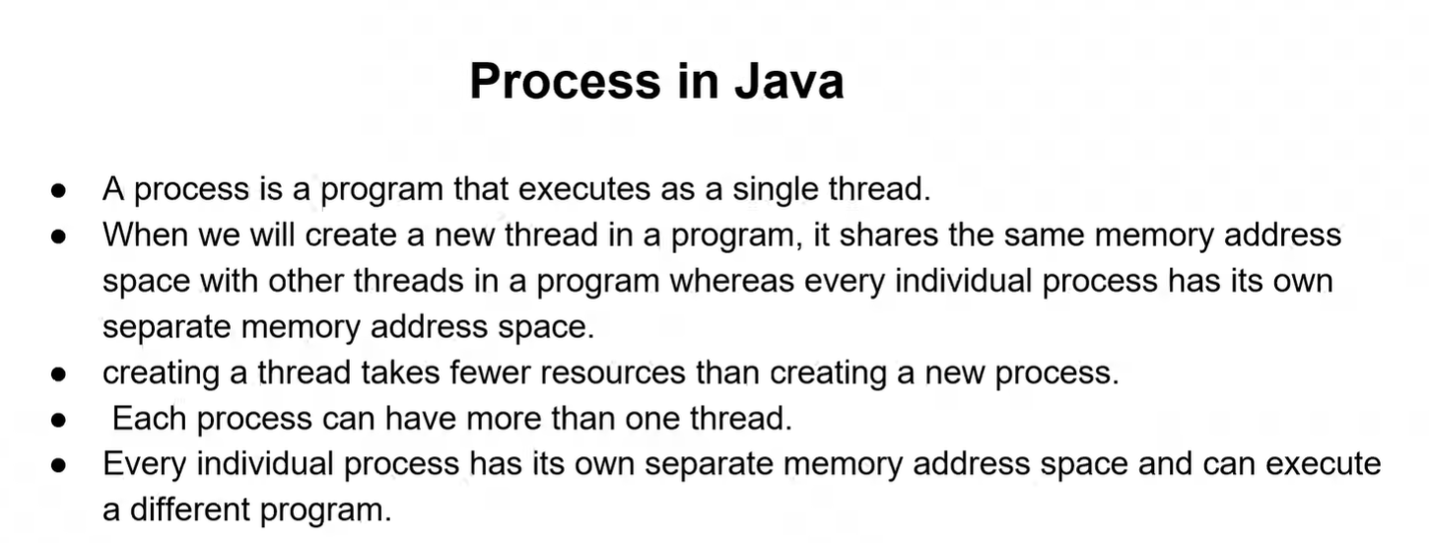

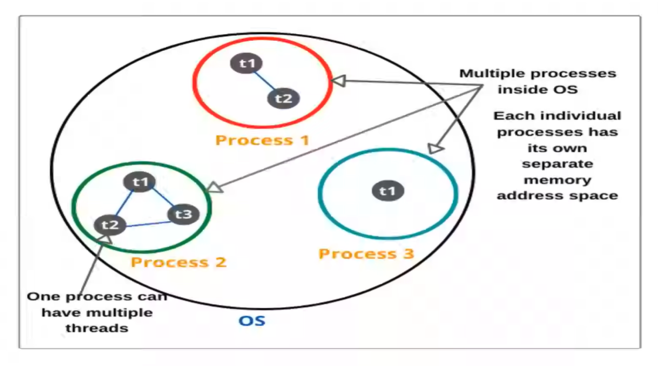

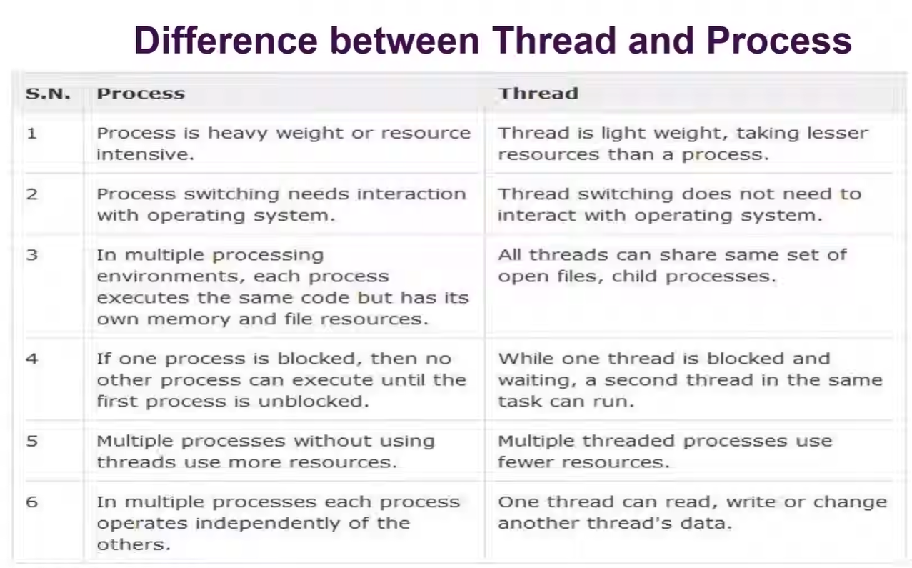

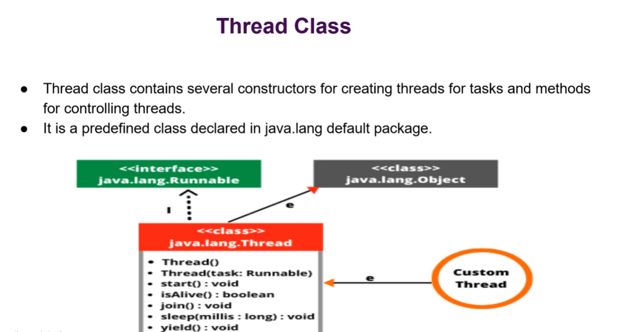

**We can’t use import for thread as like scanner class so that we are giving as :**

class Student extends thread {

// Syntax for the thread

}

**DAY - 12**

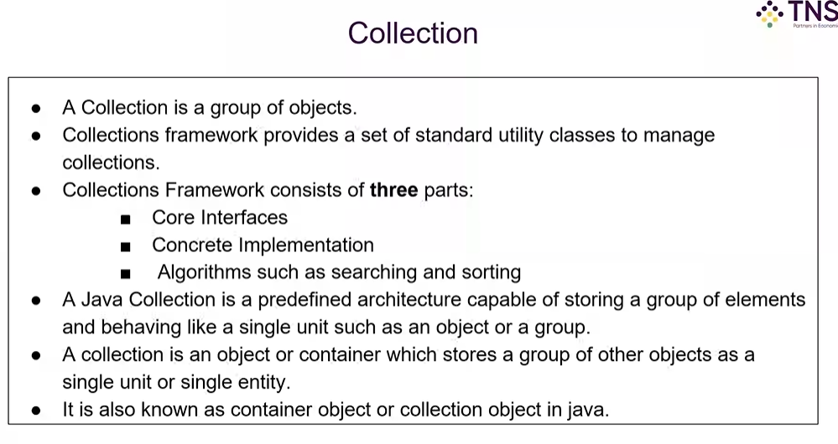

CONCRETE – Related class or connected class.

Collection – we can use different types of variables as not like array.

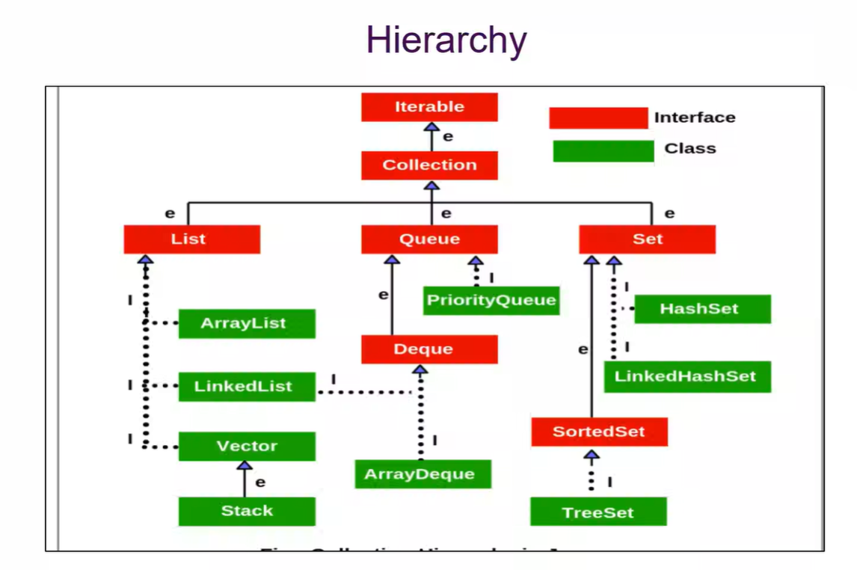

**Map –** classes are hash map and linked hash map.

(K, V) -> Key, Value

Example – Username(key) and password(value).

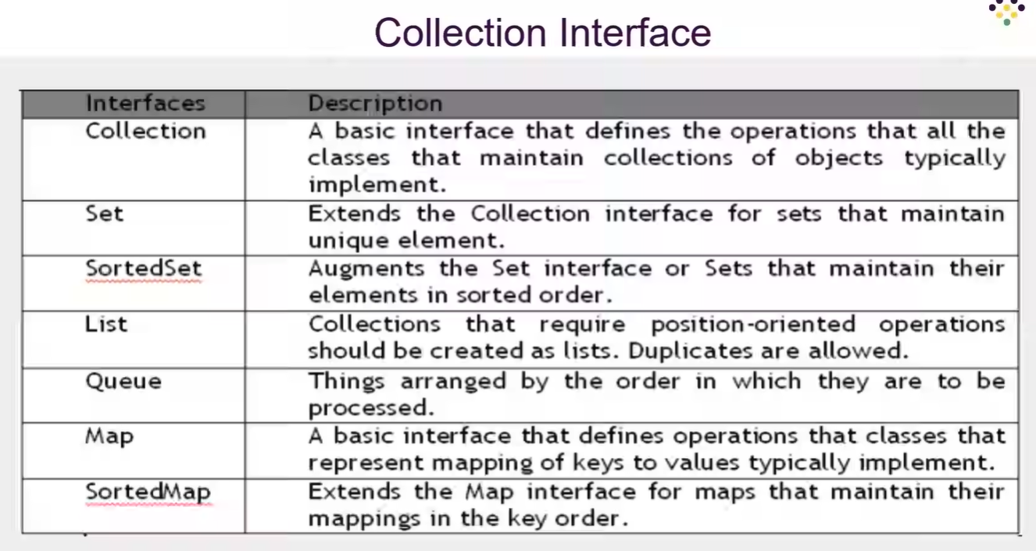

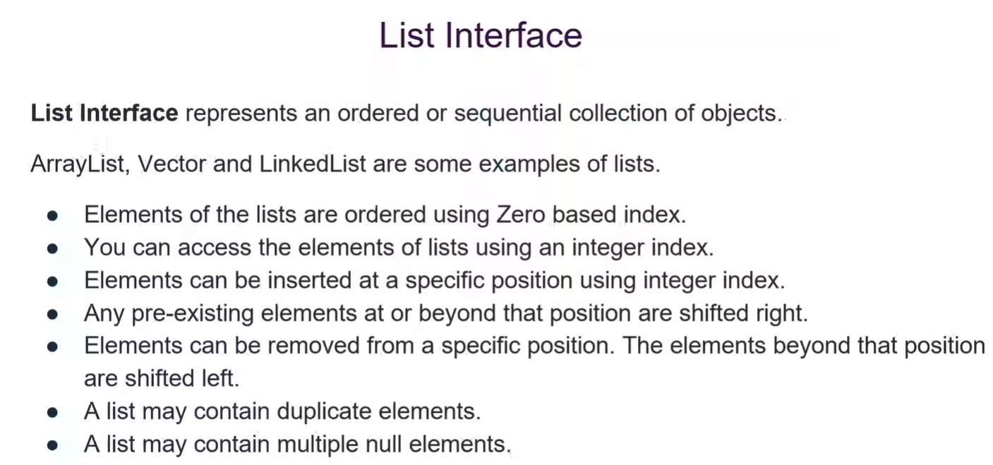

Array Advantages:

* Easy access using index value start form 0.

Array Disadvantages : are the advantages of List Interface.

* Dynamic(different types of data) allocation / not able to store different data types
* Fixed value

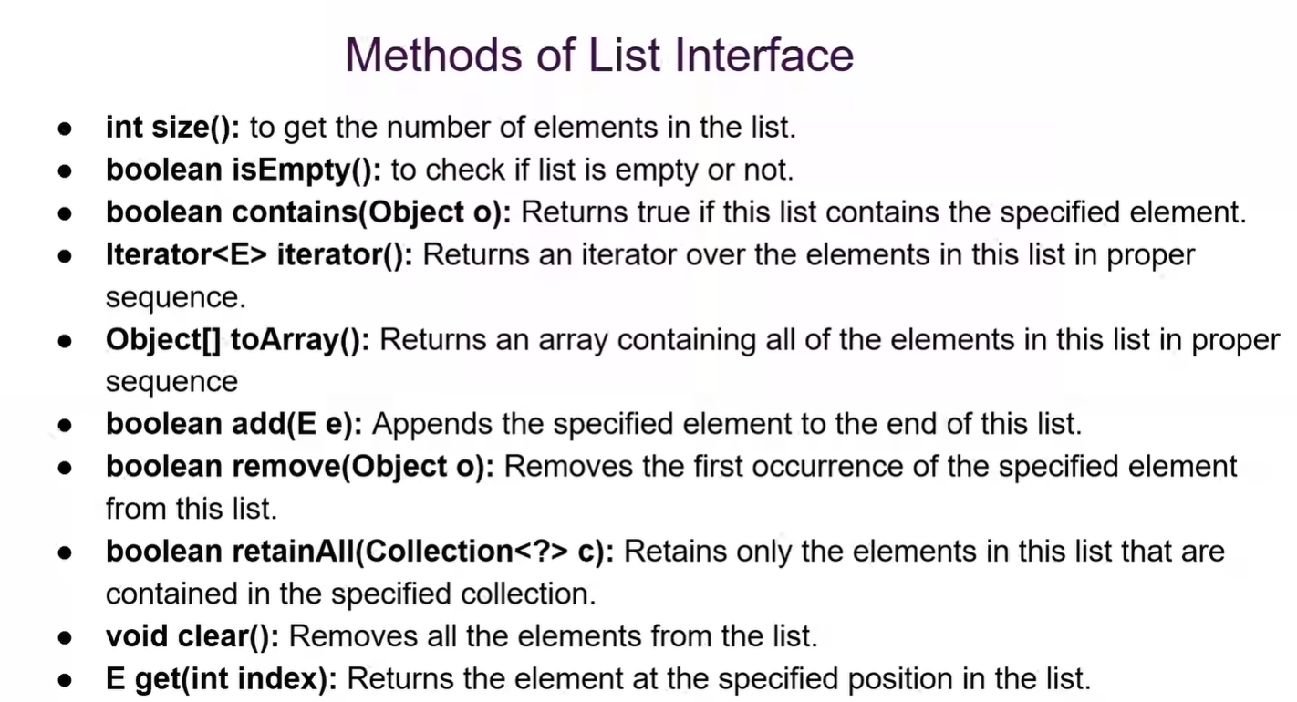

// Collection<?> c : Wildcards concept

**CRUD OPERATION :** Create, Retrieve, Update, Delete.

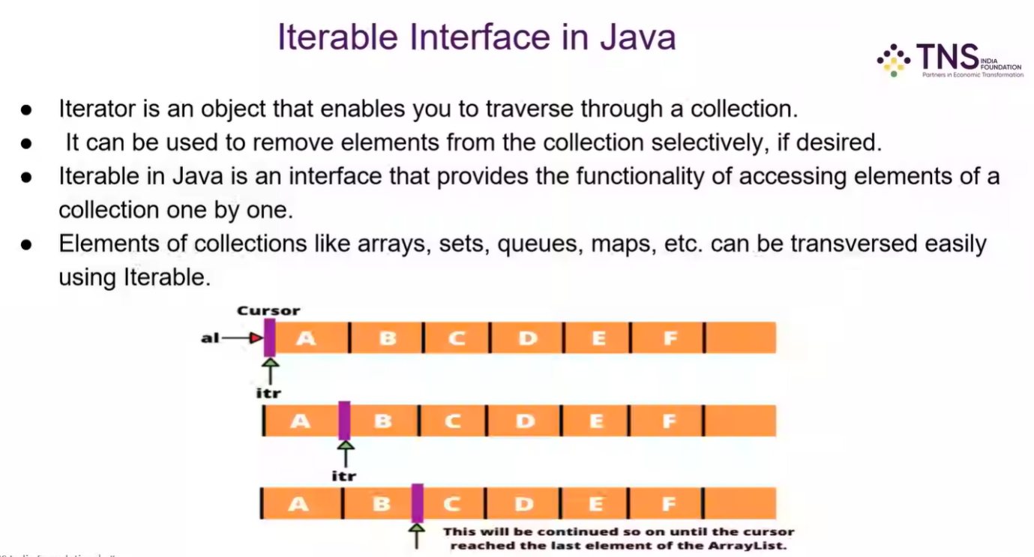

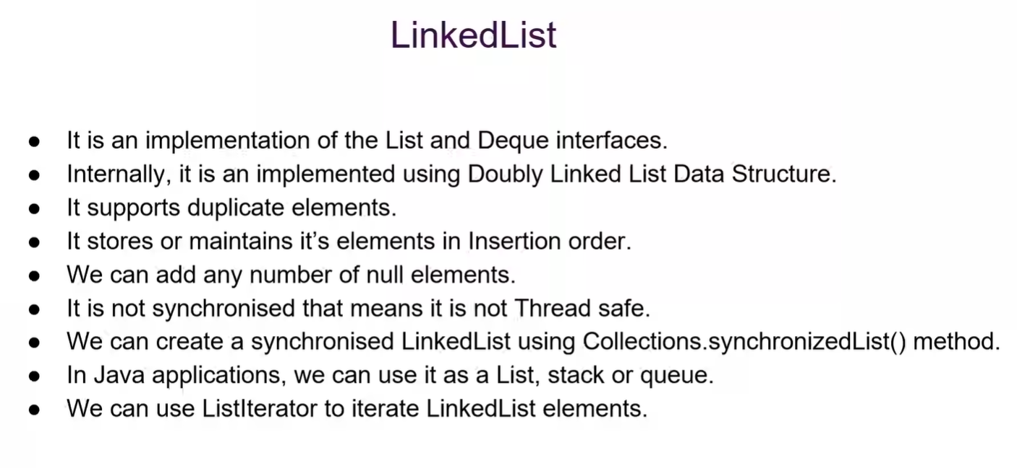

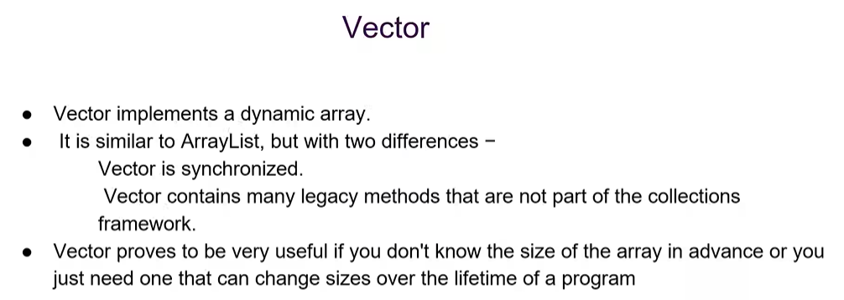

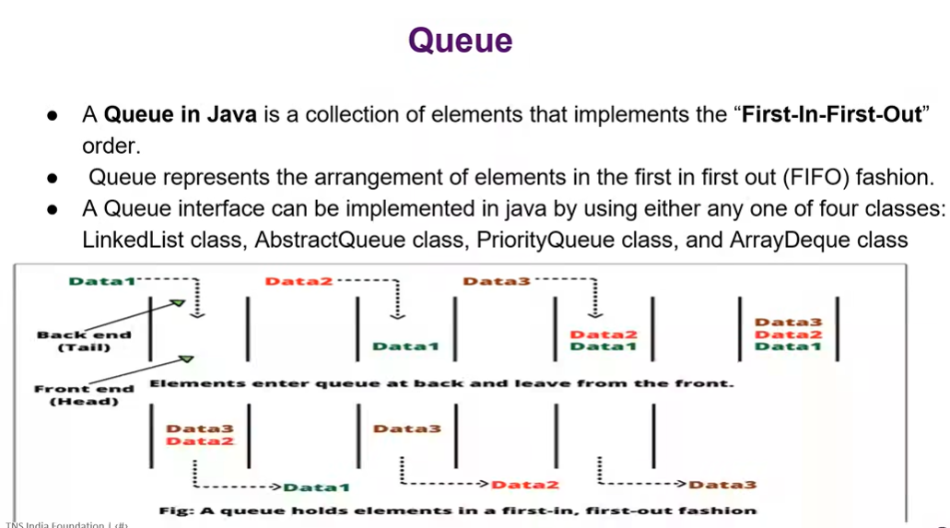

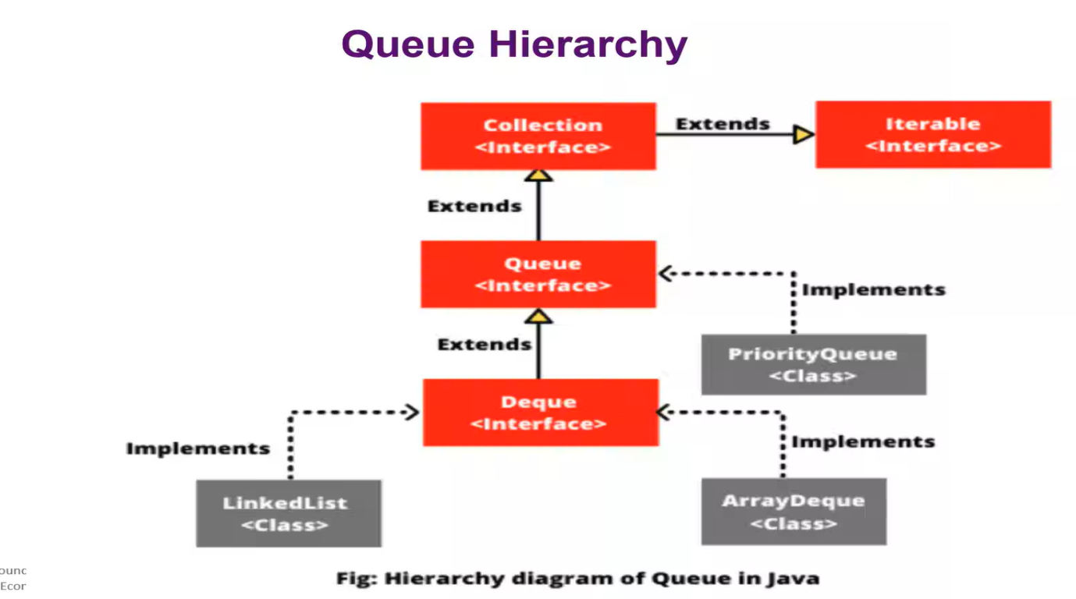

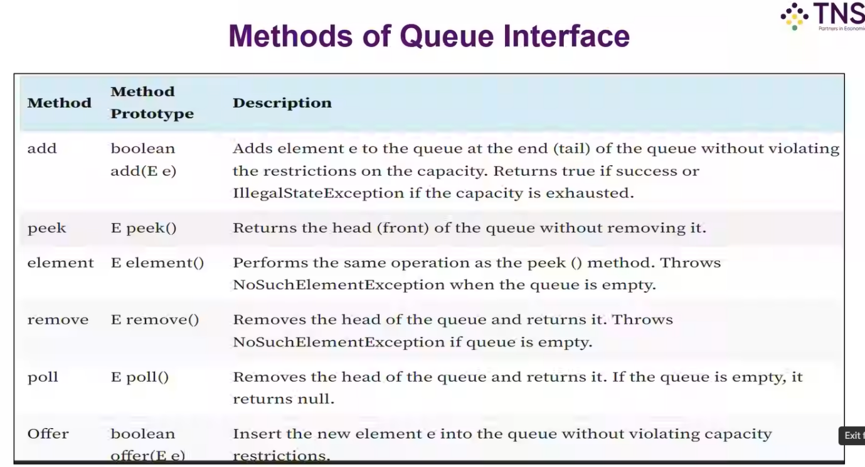

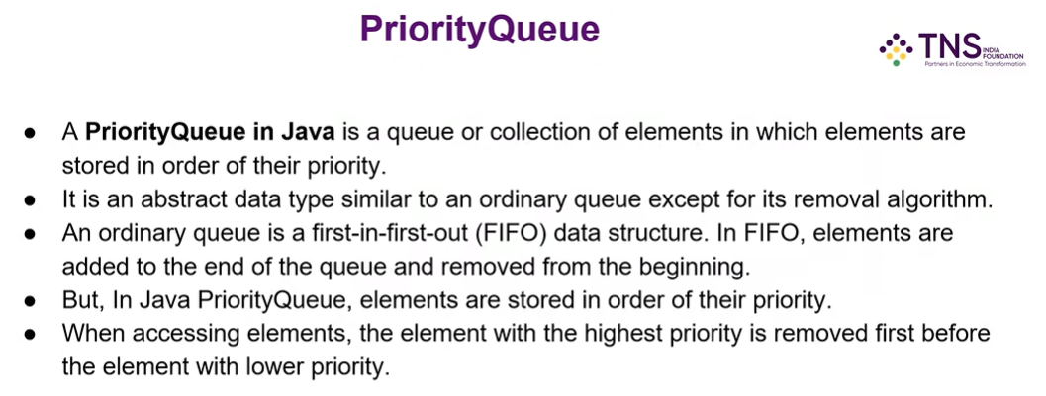

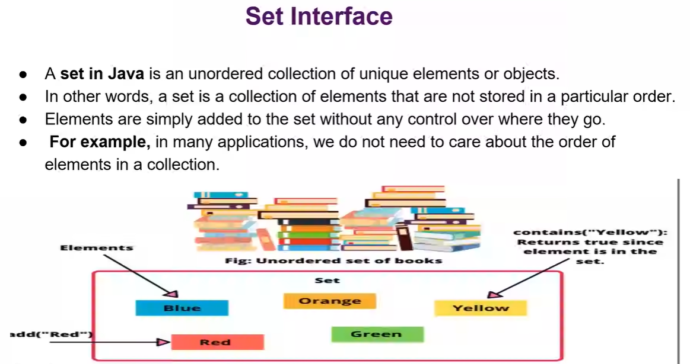

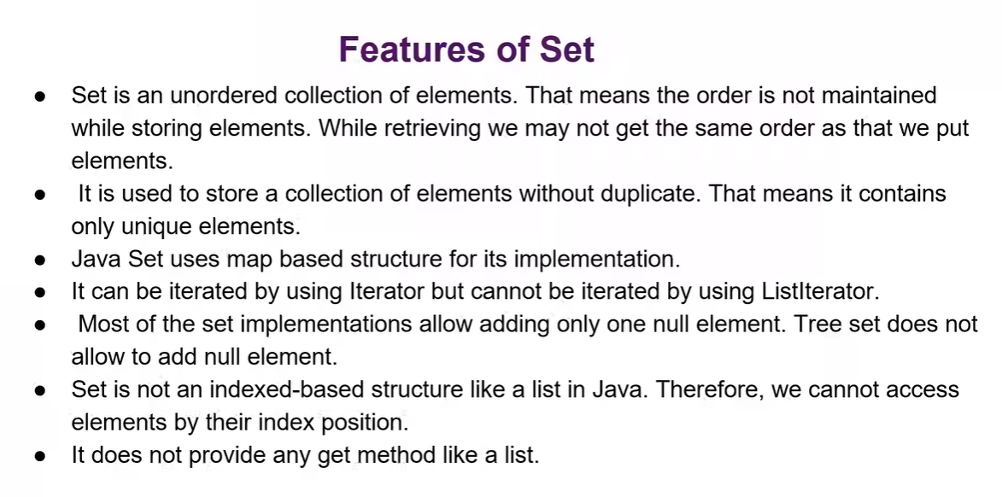

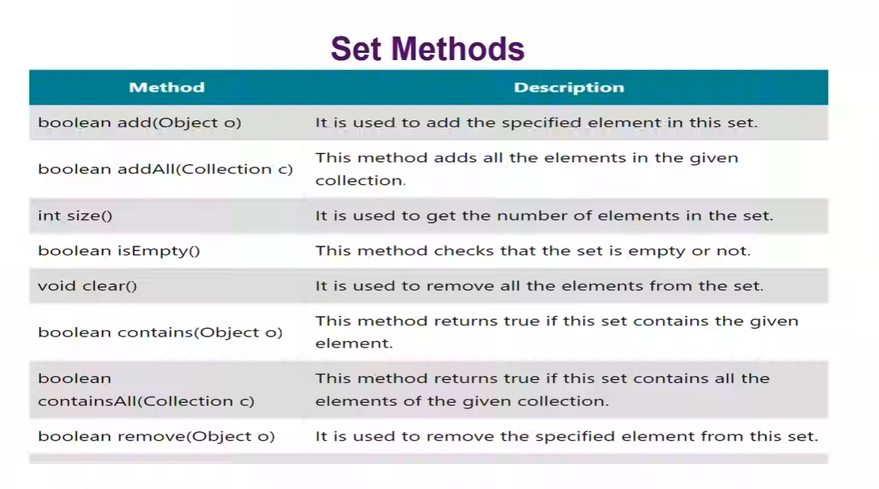

**DAY - 13**

**Lambda Expression :**

* It minimize the larger size code into very simple line.
* It is an anonymous block of code that encapsulates(wrapping under a single unit) an expression or a series of statements and returns a result.
* Syntax : (parameters) -> {statements;}
* Creation, use of single method, instead of separate concrete classes.(usages)
* Accept zero or more parameters, also without type specification.
* Implementing runnable interfaces will be () -> void.

**Diference Between Print and Return :**

Print – just print what inside the print statement

Return – Will return after some back process.

**Arrow Function :**

In Java, the arrow operator (->) is part of lambda expressions introduced in Java 8. It separates the input parameters from the body of a lambda expression, providing a concise syntax for defining anonymous functions.

The left side of the arrow specifies the lambda’s parameters, and the right side contains the code or expression to be executed. It is a shorthand notation for creating instances of functional interfaces in a more readable and compact way.

The syntax of a lambda function in Java is concise and follows a specific structure. The basic syntax is as follows:

(parameters) -> expression

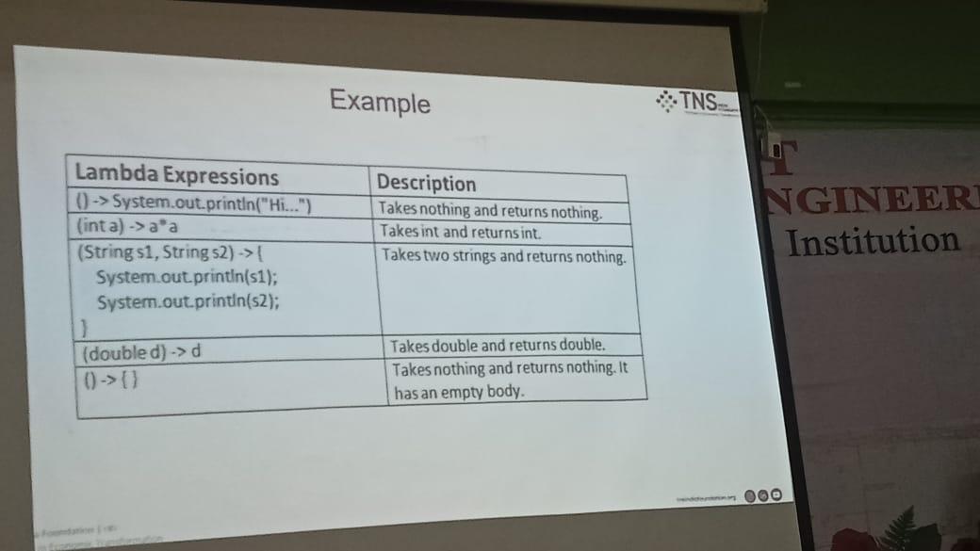

**Stream API :**

* Without storing the object we can use it. Instead of storing data we are using filter, collector and map.
* Think of a stream as a pipeline for processing data. You have a source (like a list), you apply operations to transform or filter that data, and you get a result. The key difference from traditional loops is that streams focus on *what* to do rather than *how* to do it.
* Stream API is used to process collections of objects.
* A Stream in java is a sequence of objects that supports various methods which can be pipelined to produce the desired result.
* It is a way to express and process collections of objects.
* Enable us to perform operations like filtering, mapping, reducing and sorting.

**Why Stream API ?**

* Enhances the usability of java Collection types, making it easy to iterate and perform tasks against each element in the collections. (in java DOMS model, which is used to change the data which is in blue to orange without clearing the line blue, which means overrides).
* Supports sequential and parallel aggregate operations.
* Stream API allows developers process data in a declarative way.

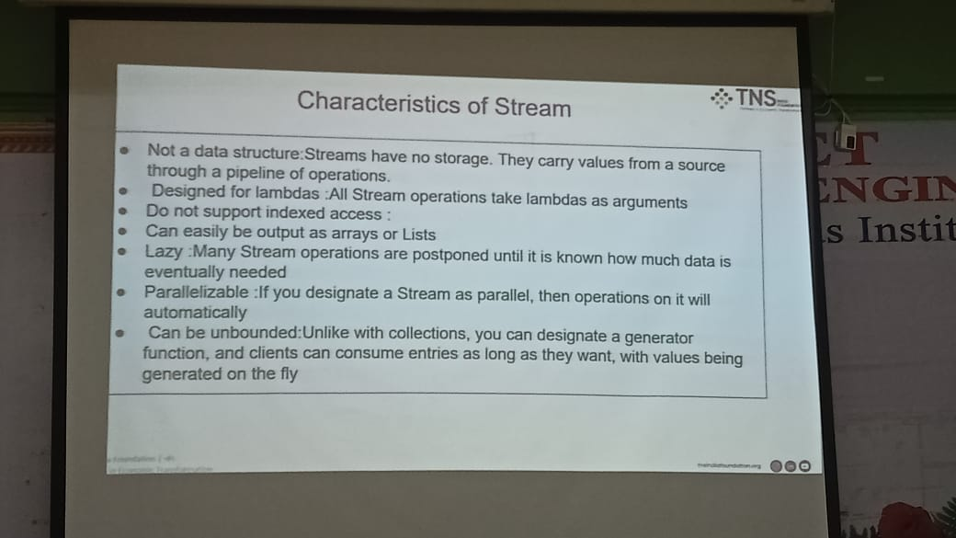

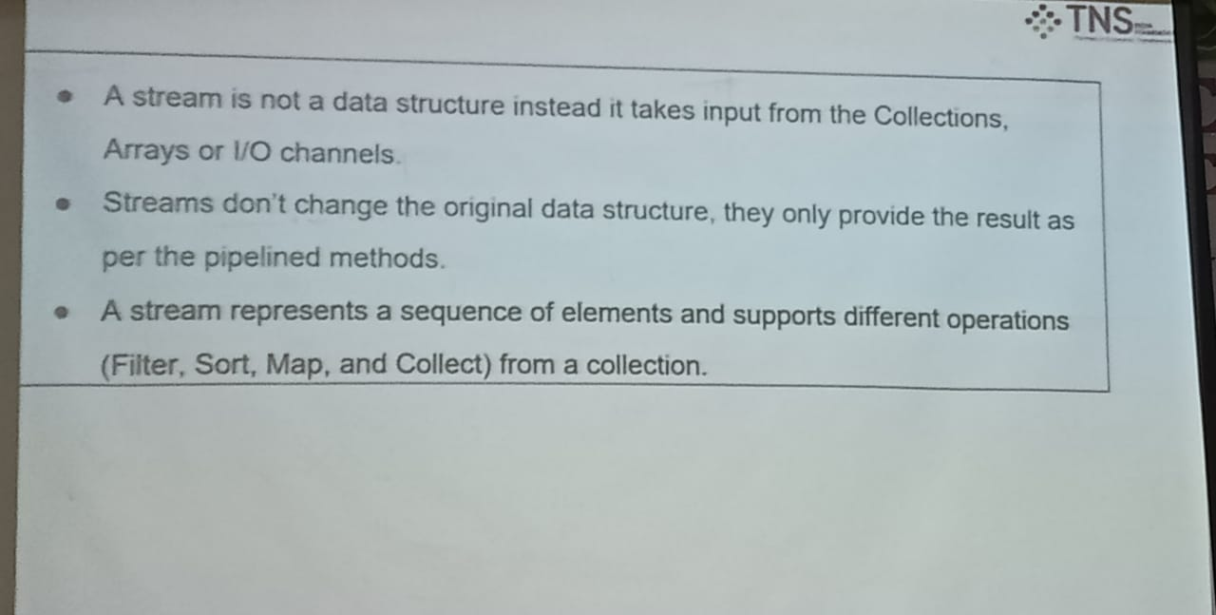

**Important Concepts :**

Collections, oops, multithreading, exception handling, JDBC.

**DAY – 14**

**JUnit :**

* It is a free, open source, software testing framework for Java.
* It is a library put in a jar file.
* It is not an automated testing tool. (automatically start testing line by line)
* Junit tests are Java classes that contains one or more unit test methods. (not an one method, they are many methods to test)

Testing – Find the bug in the code

Output – it provides the answer to the console, which is not testing. If it provides the answer then it doesn’t mean the code have not any errors.

**Unit Testing :**

* It refers to the testing of small segments of code.
* A unit indicates the smallest but of code that can be fetched out of the system.
* This small bit can be a line of the code, a method or a class.
* The smaller the chunk of code, the better it is, as smaller chunks will tend to run faster.
* And this provides a better insight into the code and its performance.

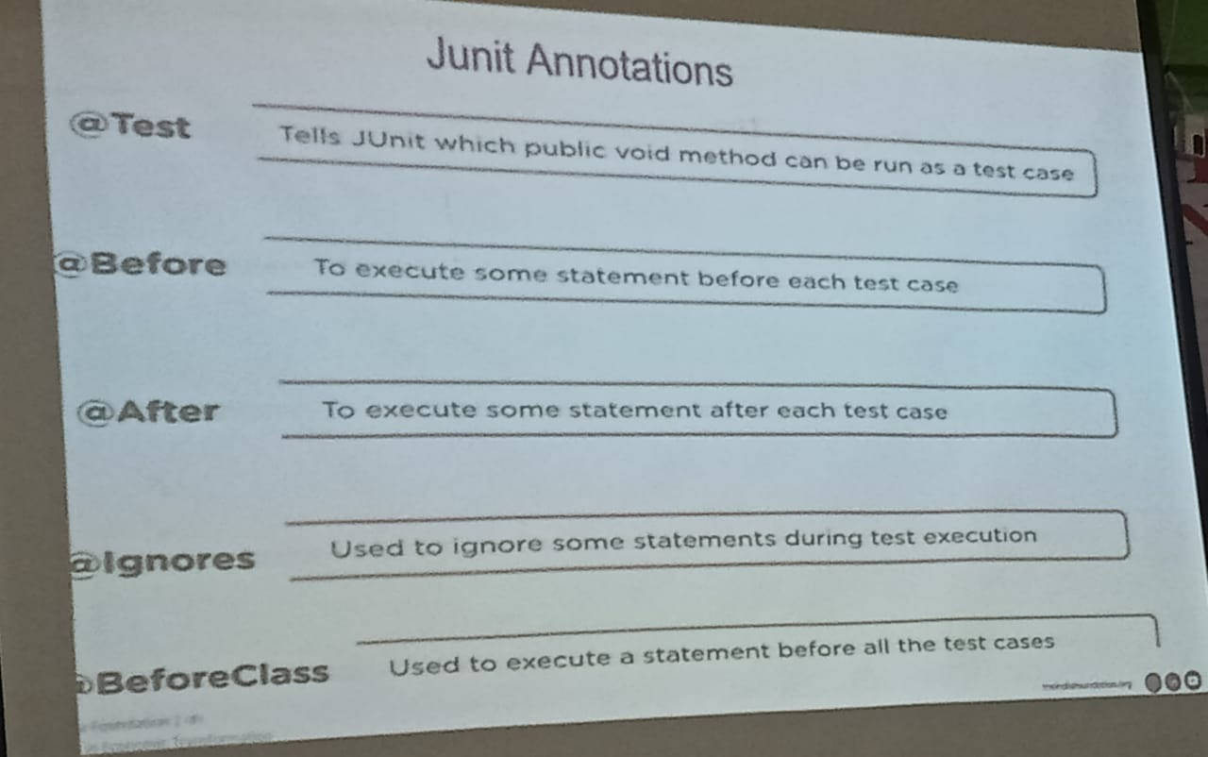

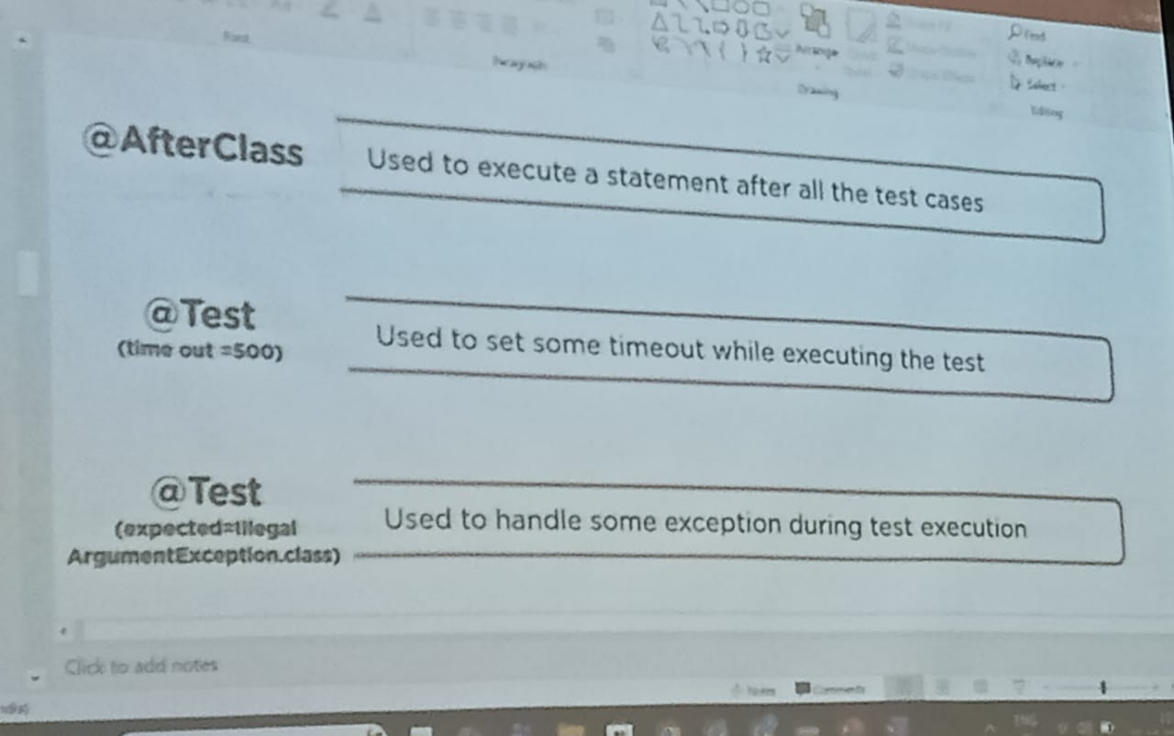

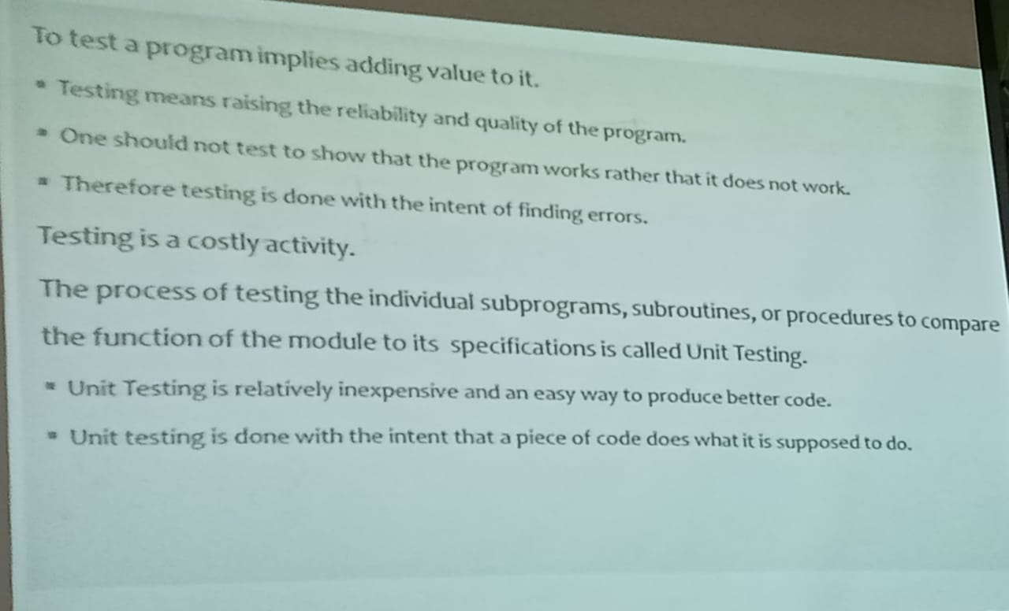

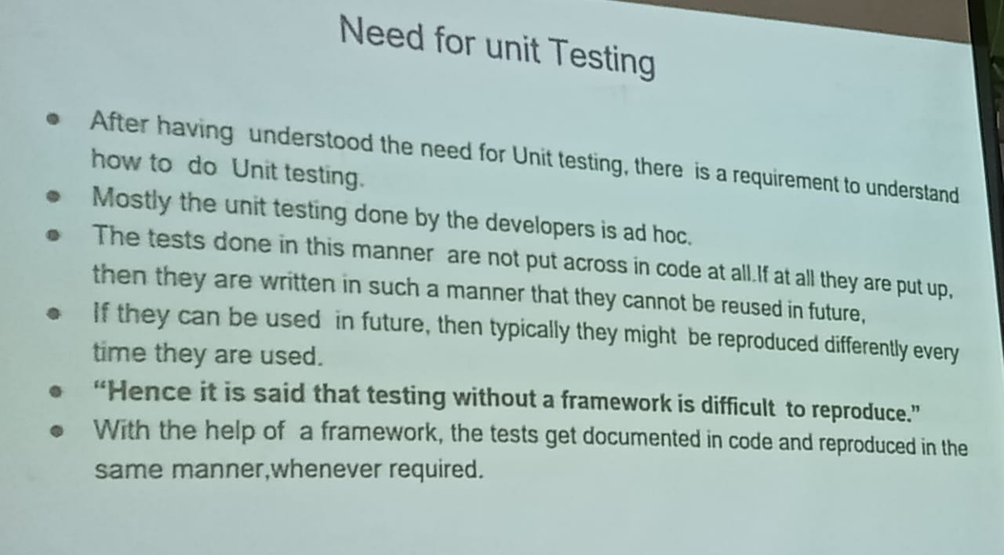

**Ad hoc –** It is technique not a method, used to test in unplanned or not preplanned situation.

**Types of Testing :**

1. Black Box Testing – without having knowledge on internal testing.
2. White Box Testing – while known on internal structure.
3. Unit Testing – we can use this even without any knowledge.

**Why unit test are important :**

* Reduce debugging time.
* Severe as documentation.
* Help to improve the design.
* Easy to run.

**Junit 5 :**

* It is the latest version of Junit
* Tests more powerful and easier to maintain ( after Java8 or later)
* Features such as describing, organizing(heirarchially) and executing tests.
* Junit5 = Junit Platform + Junit Jupiter + Junit Vintage.
* Serves as foundation for launching testing frameworks the JVM and also defines the Test EngineAPI
* Jupiter – combines new and extension model
* Vintage – Junit 3 and Junit 4, runs on both based on the platform

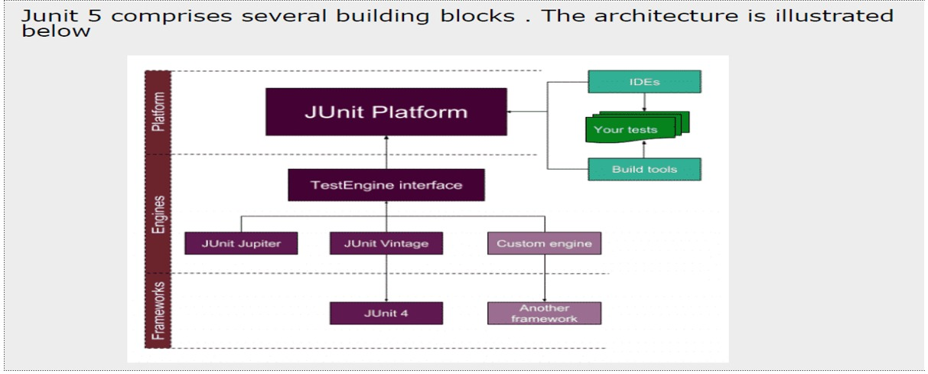

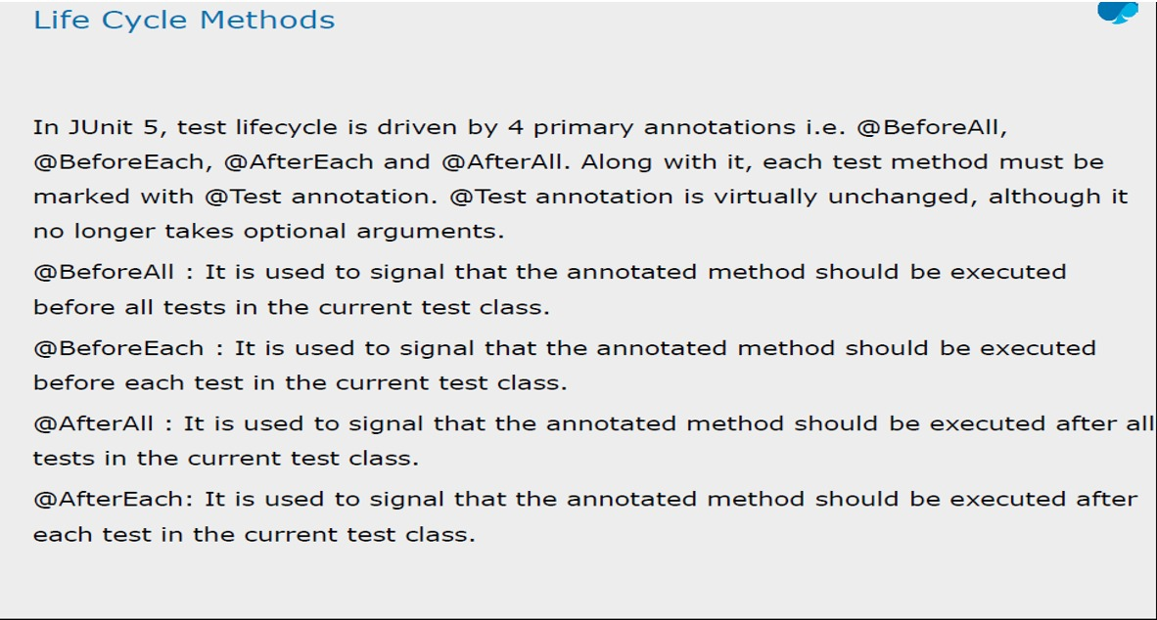

**DAY -15**

**JDBC :**

* Database connectivity and perform different manipulation (CRUD)
* Seven steps :

1. Import the packages.
2. Register/load the driver.
3. Establish the connection.
4. Creating JDBC statements.
5. Excecuting the query.
6. Closing resources.

* Architectures :

1. Type 1 – JDBC – ODBC(open database connectivity) Bridge2.
2. Type 2 – Java Native API3.
3. Type 3 – Java to Network Protocol.
4. Type 4 – Java to Database Protocol.

* Create java project -> package -> class(with main method)
* Import the SQL :

1. PostgreSQL official site -> download the PostgreSQL JDBC driver
2. MVN Repository -> version (latest & highest usage – 42.7.7) -> jar in files will download when clicks

* URL, username and password
* Load the driver (kick start)

Class.forName(“ “);

* Connection call (any name)
* Statement
* Query – SELECT * FROM table name;
* ResultSet
* Try and catch block ( catch is asked by console )